Selecting Design Mode
1. From the Dashboard, tap the Machine Setup tile
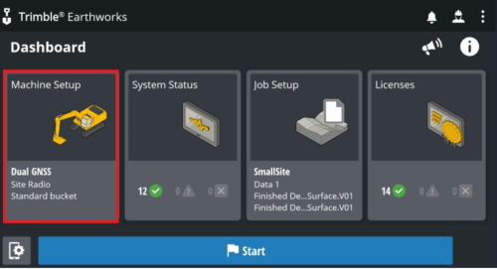
2. From the Machine Setup screen, select the Dual GNSS positioning source and tap Apply.
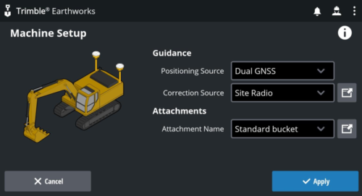
Note – The positioning source you select will determine the modes that you can select from the Job Setup screen.
3. From the Dashboard, tap the Job Setup tile. From the Job Setup screen select Design as the mode. Also select a project, and design file along with a surface and master alignment (if available).
